Navigating Precarity and Promise: A Push Pull Thematic Analysis of Platform Based Three Wheel Drivers in Sri Lanka

Bihara De Silva, Senath Thilakarathne, Anjalee Galanga, Werochana Kumarasiri, Geethma Pathirana*, Tharuka Jayathilake
*Department of Business Management, SLIIT Business School, Sri Lanka
Geethma.p@sliit.lk
Abstract: This study investigates the socio-economic motivations of Sri Lankan three wheeler drivers who engage in platform-based gig work (e.g., PickMe, Uber), applying Push Pull Theory to examine how structural pressures and perceived opportunities shape transitions into digital labor. Using a qualitative, phenomenological design, we conducted in-depth, semi-structured interviews with 16 drivers from urban and semi-urban areas and carried out thematic analysis in MAXQDA. Five themes emerged: economic precarity; urban migration and livelihood transition; platform promises and flexibility; aspirational work narratives; and daily struggles, showing how constraints such as rural underemployment and rising living costs intersect with pull factors like autonomy and income flexibility, producing a dual reality of empowerment and precarity. Situated in a Global South context, the study offers rare qualitative insight into a marginalized segment of platform workers and addresses gaps in population, geography, theory, and methodology, underscoring the need for deeper socio-theoretical engagement with digital labor transitions.

Keywords: Digital Work, Gig Economy, Platform Labor, Precarious Employment, Push and Pull Theory, Sri Lanka, Three Wheeler Drivers

INTRODUCTION
The gig economy stands out as one of the significant characteristics of labor markets in developing countries, where traditional sources of employment are scarce, and underemployment is rampant among semi skilled and youth workers (ILO, 2021; Graham et al., 2017). In the Heeks (2017) and Wood et al. (2019) studies, digital technology was seen to offer flexible short term contracts, which blurred the divide between informal and formal employment. In Sri Lanka, the urban transport sector is markedly influenced by platforms like PickMe and Uber, which transform informal employment by offering digital access to customers and income (Wijesekera & Ekanayake, 2022).
These platforms work by linking drivers and passengers via mobile applications, allowing workers to circumvent conventional employment arrangements while still participating in highly organized labor by platform algorithms and consumer reviews (Woodcock & Graham, 2019). Although this has created opportunities for income, it also creates concerns regarding the quality, stability, and long term sustainability of the work for the participants (De Stefano, 2016). Notably, the transition to platform work is not necessarily a product of free choice. Numerous individuals, particularly from economically underprivileged or rural communities, are forced into joining the gig economy for lack of better options within local economies (Jayathilaka & Amirthalingam, 2015).
In spite of its increasing significance, there has been scant scholarly interest in examining the reasons for gig work engagement in Sri Lanka from a qualitative and theory based perspective (De Mel, 2021). Existing studies concentrate on economic indicators or service levels, rather than on human narratives expressing why people embrace such work arrangements. Filling this knowledge gap, this research uses the Push and Pull Theory as a conceptual framework for investigating the socio-economic factors governing PickMe three-wheeler drivers' decision-making. Attending to their life experiences, the research reveals the complex interaction between structural pressures and aspirational rewards underpinning gig economy engagement in the Sri Lankan setting.

A. Knowledge Gap
International gig work scholarship remains skewed toward advanced economies (e.g., U.S., U.K., Australia), where labor markets, welfare regimes, and digital infrastructures differ markedly from South Asia’s; as a result, distinct regional dynamics receive limited attention (Berg et al., 2018; Wood et al., 2019). In Sri Lanka, the nature of platform participation is the product of the interaction between rural-urban circular migration, the dominance of informal employment, uneven but growing platform penetration, and economic volatility that tends to push workers towards diversification. Local credit/leasing arrangements for vehicle access, community and kinship networks that facilitate onboarding, and ambiguous regulations around transport services are the drivers of entry and persistence in this type of platform work. While existing research documents how platforms reproduce structural inequality (Graham et al., 2017; Qiu et al., 2020), it tends to under theorize socio cultural mechanisms that are salient in the Global South such as household risk sharing strategies, gendered breadwinner expectations, status and respectability associated with particular occupations, digital literacy and language interfaces, and the moral economies of ratings, tips, and customer relations. Bringing these socio-cultural dimensions into conversation with structural constraints can illuminate why drivers perceive platform work as simultaneously empowering and precarious, and how push factors (underemployment, rising costs, limited formal jobs) interact with pull factors (schedule autonomy, quick liquidity, low entry barriers) in Sri Lanka’s retail transport ecology. Under examined lenses include: (i) how kinship/community networks shape platform entry and resilience; (ii) the role of indebtedness and asset ownership in lock in or mobility; (iii) language, digital payment, and data cost frictions in adoption; (iv) local regulation and policing of para transit; and (v) collective action via unions/WhatsApp groups in negotiating algorithmic control.

B. Performance Gap
Although platforms such as Uber and PickMe offer the promise of economic opportunity, evidence has shown that gig work often does not provide long-lasting security in the Global South (De Stefano, 2016; ILO, 2021). In Sri Lanka, researchers have not yet considered the long-term livelihoods of platform and three-wheeler drivers. We know practically nothing about whether the anticipated benefits, such as increased and stable earnings, flexibility in work schedules, possibilities to own assets, or experiences of upward or downward mobility, have been realized, or how these outcomes have informed or changed future plans. This study addresses that gap by examining the expectation outcome gap across concrete dimensions: income volatility and effective hourly earnings (net of fuel, lease, and maintenance); indebtedness and asset accumulation; access to social protection and paid leave; working time, algorithmic control, and autonomy; demand seasonality and ratings; and perceived career mobility and professional identity. Using in-depth interviews and coded life history narratives triangulated, where feasible, with simple earnings/expense logs, researchers assess how platforms meet or fall short of worker expectations and identify mechanisms (fare structures, incentives, commission changes, fuel price shocks, regulatory shifts) that translate platform promises into either empowerment or precarity.
C. Theoretical Gap
Scholarship in Sri Lanka on platform work or labor has largely been framed through techno-managerial and labor economics lenses that attend to efficiency, productivity and profitability (Wijesekera & Ekanayake, 2022). The behavioral, socio-cultural and institutional affordances shaping workers’ decision making and career paths, however, remain largely unexplained. This study takes an interpretive standpoint by taking Push Pull Theory (Lee, 1966), developed in the context of migration, to consider what it means for occupational mobility in digital labor. “Push” factors i.e. underemployment, an income shock, debt, and the collapse of formal stable employment relationships, can exert influence on individual worker "pull" affordances i.e. low barriers to entry, immediate liquidity, schedule flexibility, and perceived status/modernity which are mediated through household risk sharing, gendered social norms, community social networks, platform governance/algorithmic control, and local regulation. Specifying these multilevel mediators and the dispositional or expectation outcome gap clarifies how decisions to enter work, stay in the work, and exit work is not driven only by earnings optimization but by bounded rationality, identity work, and moral economies. The contribution is twofold: (i) contextualized extension of Push Pull Theory to platformed work in the Global South; and (ii) an empirically grounded framework for Sri Lanka reconnecting efficiency outcomes to experiences of workers and socio-theoretically information.

D. Methodological Gap
Empirical research on gig workers in South Asia has predominantly relied on survey based, descriptive quantitative designs (Rani & Furrer, 2021). While valuable for breadth and comparability, these approaches often suffer from limited contextual depth and struggle to surface workers’ underlying motives, tradeoffs, and constraints. Qualitative methods, especially in-depth, semi-structured interviews analyzed thematically, remain underutilized despite their capacity to elicit tacit meanings, household risk-sharing logics, indebtedness dynamics, algorithmic experiences, and place-specific coping strategies. To fill this gap, our research employs a qualitative, phenomenological design focused on drivers’ stories, and then utilizes thematic analysis to produce nuanced, situated insights into why and how these Sri Lankan three wheeler drivers enter, stay in, or leave platform work.
E. Research Questions and Objectives

This research aims to investigate how the combination of socio economic pressures and perceived benefits associated with the gig economy, operates on the labor choices made by Sri Lankan three-wheeler drivers. More specifically, the research examines the push factors of precarious work, a lack of rural employment, and income uncertainty, and pull factors of flexibility, autonomy, and daily earning opportunities posed by platforms like PickMe on rural or economically disadvantaged individuals. The utility of Push and Pull Theory facilitates a structured understanding of how external constraints combine with the aspirations of individuals to motivate occupational mobility. Located in the Sri Lankan context where informal work is normalized and gig platforms are emerging a knowledge contribution is made through a theoretical and empirical lens to understanding labor mobility within digital economies in the Global South.

- LITERATURE REVIEW

The rapid growth of gig economies around the world has led to increasing academic interest in the implications of digitally mediated labor. In developed economies, research has predominantly focused on issues of algorithmic management, autonomy, and changing employment relations (Wood et al., 2019; De Stefano, 2016). The Global South, however, represents a very different context whereby gig work is more journalistically framed within the more extensive challenges of informal labor markets, rural urban migration, and some forms of underemployment (Graham et al., 2017; Heeks, 2017).
In the case of Sri Lanka, online platforms such as PickMe and Uber have created employment possibilities in the urban transport sector. These platforms bring passengers and drivers together through mobile apps and provide flexible work conditions. Yet, current research on gig work in Sri Lanka disproportionately concentrates on operational matters, consumer satisfaction, or economic success of platforms (Wijesekera & Ekanayake, 2022), with less examination of the everyday experiences of gig workers, and more specifically, three-wheeler drivers operating from rural or low-income settings.
South Asian research on labor transitions indicates that push factors like economic insecurity, employment scarcity, and political instability are typically prime drivers of migration or entry into informal employment (Jayathilaka & Amirthalingam, 2015; ILO, 2021). On the other hand, pull factors like the prospects of flexible timing, urban earnings, and autonomy attract workers to platform work (Berg et al., 2018). Although these processes are well recognized, there is limited scholarship that consolidates both push and pull factors into an explanatory framework for gig work motivations.
Push and Pull Theory, initially formulated to model human migration patterns (Lee, 1966), offers a useful framework to understand work transitions in the informal and platform-based gig economy. The theory has been applied to labor market research to describe how workers are "pushed" by unfavorable circumstances into employment and "pulled" by desirable prospects (Benson & Brown, 2011; Rani & Furrer, 2021). Although highly pertinent, Push and Pull Theory has been underused to understand digital gig work in South Asia, especially for transportation workers.
In addition, most current research on gig work utilizes quantitative approaches, frequently drawing on surveys or platform data that do not offer much in terms of understanding workers' personal and socio-cultural motivations (Schmidt, 2020; Woodcock & Graham, 2019). Little research has used qualitative, narrative-driven approaches to examine how platform work is lived at the individual level, particularly for marginalized groups who use gig work as a central livelihood strategy.
Moreover, recent studies underline the precariousness of gig work and the psychological and emotional toll it takes on workers, too. For instance, studies conducted in India and Indonesia document that gig workers frequently experience job precarity and income uncertainty, and they often do not have any real social safety nets put in place, which contributes to vulnerability and stress (Kumar et al., 2021; Anwar & Graham, 2020). Similarly, gig workers in Sri Lanka contend with costly overheads, overwhelming competition in online delivery spaces, very little health insurance, or savings for retirement. Regardless, workers still desire gig work rather than the formal economy due to their perception of agency and dignity when compared to exploitative and stigmatizing work within their neighborhoods (Baruah, 2017).
Moreover, family responsibilities and cultural expectations also play a major role in gigging decisions. Men, for instance, are likely to be main earners in patriarchal societies such as Sri Lanka, and gigging is a convenient option that enables them to balance the demands of work with those of the family. Nevertheless, the lack of stable income and long term employment benefits can exacerbate economic stress, especially for individuals with dependents or those who are repaying vehicle loans (ILO, 2021).
To represent the geographic aggregation of academic research on the gig economy, a choropleth world map was created based on a quantitative analysis of peer reviewed articles between 2020 and 2025. As shown in Figure 1, most of the research comes from Asian countries, followed by North America, Europe, and Oceania. Notably, countries such as India, China, Sri Lanka, and Indonesia dominate the literature, collectively accounting for a significant proportion of platform-based labor research.
This diffusion of work highlights the growing intellectual interest in gig work in developing and emerging economies, where diffusion of digital platforms like Uber, Grab, and PickMe has redefined traditional labor patterns. In comparison with publications from African and South American nations, they are limited in scope, indicating a geographical imbalance in taking note of gig economy patterns throughout the globe. This aligns with previous calls (e.g., Anwar & Graham, 2021; LIRNEasia, 2023) to scholarship beyond Anglophone and Global North studies.
Figure 1. Choropleth Map Showing Percentage Distribution of Gig Economy Research by Country (2020 2025)
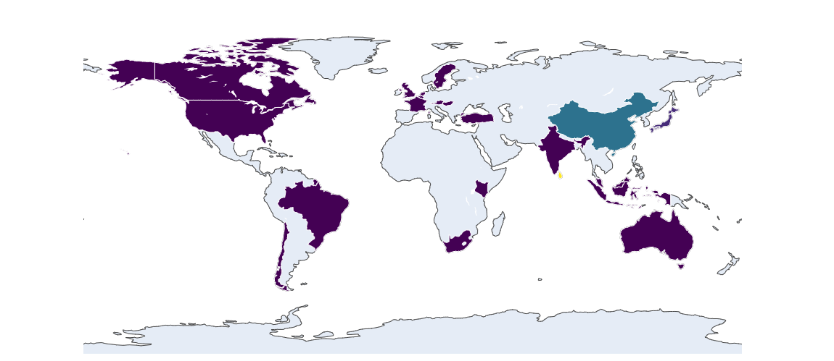
Source: Created by Authors Using plotly.com

The heat map also demonstrates the fact that, despite its size, Sri Lanka has been increasingly appearing as a case study in gig economy research. This point emphasizes the value of exploring local socio economic and regulatory contexts, which informed the experience of gig work in different regions. The data visualization strengthens the case for additional contextually grounded comparative analysis of platform work.
This research contributes to underrepresented issues by framing the research in existing literature on informal work, gig work and socio economic mobility within the Global South. Those underrepresented issues include the application of Push and Pull Theory to labor transitions in digital economies, the lived experience of rural and semi urban three wheeler drivers, emotional and pecuniary sacrifices in undertaking precarious gig work, and the imperative of qualitative evidence to understand the nuance of worker motivations in Sri Lanka's evolving platform economy.
- METHODOLOGY
This research utilized a qualitative study approach anchored on phenomenology to explore thoroughly the lived experiences of three wheeler drivers who participate in gig work via the PickMe and Uber platforms. Researchers adopted phenomenology as a method because it helps inform us about the day to day experiences of people in their socioeconomic surroundings (Creswell, 2013).
This study looked at the subjective perceptions, motivations, and constraints concerning the structural push factors (e.g., unemployment, rural underdevelopment) and aspirational pull factors (e.g., flexibility, “autonomy, and income potential”) concerning the drivers’ involvement in work on platforms. Since this study was concerned with meaning, it explored the drivers’ motivations in as much depth as possible, which enhanced understanding of the psychology and the socio cultural factors that influence gig work in Sri Lanka.
A.Sampling and Participants
The purposive sampling design was adopted in selecting participants who had appropriate and diverse experience with PickMe and Uber. Sixteen (n=16) three-wheelers were interviewed from urban and semi-urban areas like Colombo, Kandy, Hatton, Gampaha, and Ratnapura. The sample represented both full-time and part time drivers, self-owned vehicle drivers, and hired or borrowed vehicle drivers. Recruits were enrolled up to the point of data saturation, where no new information was being revealed, and repetition of themes was observed. This was to guarantee the richness and adequacy of data for phenomenological analysis
B. Data Collection
The primary method of data gathering was semi structured, in depth interviews. These interviews were administered in Sinhala and later were translated into English for analysis. Each interview was in the range of 30 45 minutes and audio recorded with the participant’s consent. Being open ended, the interviews allowed for the participants to reflect on their beginning in gig work, daily work process focuses, challenges experienced, perceived benefits and expectations.
C. Data Analysis
The MAXQDA software was used to carry out a qualitative analysis of the interview transcripts. The analysis entailed the steps of thematic phenomenological analysis as defined by Moustakas (1994) and Braun & Clarke (2006): (1) becoming familiar with the data through repeated readings of the transcripts, (2) initial coding of meaning units and highlighting meaningful statements, (3) agglomeration of codes into thematic categories, (4) verification and refining themes so that they were coherent within and different from one another externally, and (5) organizing themes into a narrative that accounted for the content of participants' lived experience. It was noted that code development was inductive and iterative, as opposed to coding being imposed beforehand as articulated by Braun and Clarke (2006). After codes were developed into thematic categories, the themes were compared to those in the theoretical framework of Push and Pull Theory to examine in what ways the participants' accounts illustrated both structural pressure and felt opportunities.
D. Trustworthiness and Ethical Considerations
To ensure credibility, the research followed criteria of credibility, transferability, dependability, and confirmability (Lincoln & Guba, 1985). Credibility was enhanced through triangulation of respondent backgrounds and iterative member checking. Transferability was ensured by providing thick descriptions of context and participant experiences. Dependability was addressed by maintaining an elaborate audit trail of coding and analysis processes in MAXQDA. Confirmability was ensured by documenting research reflection and being neutral while conducting interviews and coding.
Informed consent was obtained from participants, and all personal identifiers were removed to maintain confidentiality. Voluntary participation was welcomed, and respondents could withdraw at any point.
This research approach enabled a detailed, contextually grounded understanding of how Sri Lankan three wheeler drivers choose gig work, how they manage its limitations, and how they perceive its sustainability in terms of their overall life goals.

FINDINGS AND DISCUSSION
Thematic analysis of PickMe and Uber three wheeler drivers' interviews with sixteen drivers revealed five general themes that closely correspond with Push and Pull Theory: (1) Economic Precarity as a Push Factor, (2) Urban Migration and Livelihood Transition, (3) Platform Promises and the Allure of Flexibility, (4) Aspirational Work Narratives, and (5) Daily Struggles in the Gig Economy.
A. Visualizing Thematic Relationships through a Static Map
In order to further demonstrate how interview stories mapped against the Push and Pull Theory, a Sankey Diagram (Figure 2) was constructed to illustrate visually the correspondence between the core themes and underlying codes. This network diagram illustrates how individual motivations and constraints collapsed thematically around patterns in the data.
Figure 2. Sankey Diagram Illustrating Push and Pull Motivations for Gig-Based Three-Wheeler Drivers in Sri Lanka
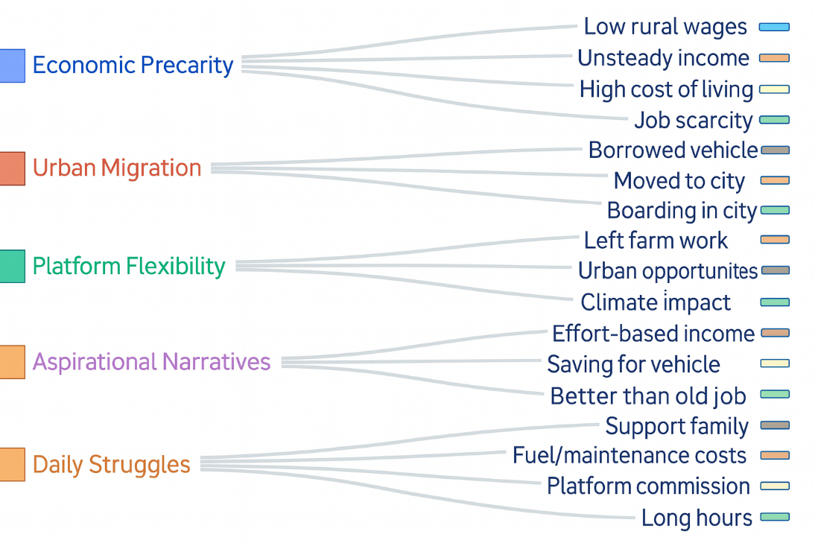
Source: Develop by authors based on Interview Transcriptions
The diagram illustrates the thematic flow from higher-level motivators (push and pull factors) to document codes derived from interviewees. It also demonstrates how perceived structuring challenges (such as job scarcity in rural areas and unstable incomes) and perceived structural advantages (such as flexible daily hours and aspirational goals) shape the decision to work in relied upon in the pandemic era of work. It is visualized in push and pull theory and based on the in-depth, contextual narratives of sixteen PickMe and Uber drivers across urban and semi-urban Sri Lanka, showing how push and pull factors influence the decision to engage in platform-mediated work.
This visual structure not only presents the richness and coherence of qualitative coding for sharing the process of some forms of coders' work, it also illustrates the complexity of vocational motivations in a tiered outcome from the interacting motivational forces a driver has on decision-making about work. For example, "Low wages in rural areas," "Lack of job availability in rural areas," and "Rising costs of living" are under the economic precarity push theme, exemplifying some structural push factors; while the flexibility theme, which includes "Daily earning flexibility" and "Autonomy of time" showcases some appealing pull factors.
In graphically illustrating these connections, the figure substantiates the primary argument of this research: that gig work participation among Sri Lankan three wheeler drivers is not the result of a single factor but a complex interplay between need and opportunity. It also substantiates the efficacy of the Push and Pull model in explaining labor mobility in Global South platform mediated economies.
B. Economic Precarity as a Push Factor
The majority entered the gig economy as a response to precarious or inadequate prior employment. Many of the interviewees used to be daily wage workers, masons, or agricultural laborers in rural areas, where work availability was both seasonal and poorly paid. One interviewee explained, "Earlier, I used to do daily wage work in my village, but it did not pay adequately.". Therefore, I came to Colombo." The above quote illustrates how economic uncertainty in the rural areas was a strong push factor compelling workers to seek alternatives in urban locations. Also, some of the drivers employed borrowed or hired vehicles as they did not have enough money to purchase one, further illustrating economic vulnerability. Some others identified rises in the cost of living and inflation as making their former livelihood activities untenable. This vulnerability was heightened by the fact that there was no local generation of employment, especially for the less educated or technically trained, to force them to seek alternative sources of income.
C. Urban Migration and Livelihood Transition
Most of the drivers interviewed moved from rural towns such as Kandy, Hatton, and Kahatagasdigiliya to urban areas of Colombo, Ratnapura, and Gampaha. This was because there was generally insufficient hiring opportunities for drivers in rural towns, along with a greater number of requests for a drive in the city. A driver from Kandy said, "Honestly, there are fewer hires that occur within Kandy." PickMe or Uber drivers were definitely not welcomed. As these migration stories show, mobility has been a way for drivers to move out of a lingering labor market in their home places. Drivers also reported leaving agricultural work as climate uncertainties and land ownership were making farming or subsistence farming nonviable. Therefore, moving from rural towns into cities was both an economic transition and an intentional act of survival planning.
D. Platform Promises and the Allure of Flexibility
The excellent pull factors of daily earnings, time autonomy, and freedom of self regulation were very appealing for the drivers. They mainly reported that they enjoyed the gig work over traditional employment because there was no scheduled schedule. To quote one of the respondents: "If we ride without regard to our trouble, we could even earn LKR15,000 to LKR20,000." "If we are lazy, we only earn LKR5,000 to LKR6,000." This example is telling; although an effort based job, the drivers expressed that making a good living was contingent upon their own choices and decisions again in line with the neoliberal notion of entrepreneurial self production. The drivers reported that the platform also allowed them to take a break for a little while to attend to family or religious obligations, which could not have been accommodated in their daily factory work or construction jobs. Others appreciated the autonomy of being self employed, while recognizing they were still dependent on the app for jobs.
- Aspirational Work Narrative
Other participants placed gig work as not merely a necessity but also as the stepping stone to a secure future. Though their current income was low and intermittent, they were also deemed to be superior to before. "This job is more reliable. Customers are always there in Colombo," said one of the drivers. Others viewed their work as decent and superior to demeaning manual labor. Even those who rented vehicles or lived in temporary boarding houses saw the opportunity as meaningful and forward looking. Aspirational themes included saving money to eventually buy their own three wheeler, supporting children’s education, or someday transitioning to owning a small business. One participant shared, “I’m saving up to buy my own vehicle. When I do that, I earn more without the car owner having to pay me commission." These accounts proved both enduring and patient.
- Daily Struggles in the Gig Economy
Despite the perceived advantages, the drivers shared common problems of excessive operating costs, commission withdrawals, and physical wear and tear. They all claimed to have spent over 50% of their income on fuel, maintenance, or car rentals. "I make Rs.. 2000 on rides, and I pay about Rs.1000 on the fuel," one driver said. Additionally, 20% platform commissions were frequently mentioned as a nuisance. Economic pressures, with no social protection changes significantly burdened the drivers, particularly those with families or vehicle loan repayments. Others faced challenges from revisions to app algorithms, which sometimes served to diminish transparency, and/or made new drivers favored. Long hours spent in traffic fueled fatigue and fear of accidents or sudden illnesses with no access to medicine intensified the difficulties of being an injured worker. Some drivers were additionally worried due to lack of grievance procedures or collective bargaining, thus furthering the insecurity of working conditions.
Together, these results are a set of tensions between push and pull forces for Sri Lankan gig drivers. Rural or underemployment pushed people into the platform economy via structural disadvantage, and the platform then provided a set of affordances that combined a sense of empowerment with precarity. The Push and Pull Theory captures this tension well, indexing both desire and need that push drivers into the platform.

DISCUSSION
The results of this research confirm the importance of the Push and Pull Theory to elucidate engagement in gig based employment with a case example of Sri Lanka. Push factors such as economic vulnerability, unemployment, stagnation in rural areas, and traditional livelihoods not yielding success were compelling factors driving people to search for an alternative livelihood. The structural drivers are also consistent with current literature, which situates economic need as a pivotal precursor for gig work participation in emerging economies (Anwar & Graham, 2021; Edirisinghe & Wimalaratana, 2025).
On the other hand, this study also reveals how pull factors such as flexible timing, perceived autonomy, and income potential have an equally compelling role in the decision-making at the individual level. The aspirational dimensions of gigging are inescapably tied in here as gig workers envision platform work not just as an avenue of escaping hardship, but also as an avenue of upward mobility. Using both factors signifies a dual motivational approach to reinforce the theoretical significance of the Push and Pull Theory in summarizing coercive and attractive forces to enter into the gig economy.
Studying helps fill various gaps in knowledge. First, it serves to fill a geographical gap by providing qualitative knowledge from Sri Lanka, which has received less attention than hegemonic Global North scholarship and economies within the established parts of Asia. Second, it helps fill a population gap by studying three-wheeler drivers, a population often overlooked in research on platform labor studies, which focuses much of its attention on delivery riders or ride hailing car drivers. Third, it helps fill a methodological gap by using a phenomenological qualitative method, providing rich first-person accounts in comparison to survey-heavy gig economy research. Finally, it helps fill a theoretical gap by theorizing the Push and Pull Theory in a context where few scholarly writings have critically engaged both structural constraints and personal wants in an integrative framework.
In addition, the study contributes to academics and theorizing by conveying the intertwined nature of push and pull factors. For example, migration from rural areas to urban centers can be understood as a push factor by responding to economic deprivation in rural areas and a pull factor as workers are attracted to the prospects of platform work in cities. Likewise, while workers are attracted to flexible working hours, algorithmic control and social protections make the flexible working aspects of these jobs more complicated; both are suggested to indicate a combination of agency and structural disadvantages.
The debate also positions the Sri Lankan experience in international and global dialogues. In contrast to Western-focused gig economy scholarship that emphasizes (or fetishizes) autonomy and tech-focused entrepreneurship, this paper uses the lens of labor based on economic vulnerability and precarity as the basis for platform work in the Global South. It suggests theoretically centered contextualized research that combines structural and voluntarist explanations of gig work.
The findings outlined here are useful and relevant in the Sri Lankan context, and in general apply to other comparable emerging economies where gig platforms are an emerging mode of organization of work for the informal economy. In particular, youth-dominant countries with corridors of migratory transitions from rural to urban labor markets and weak labor protections may benefit from the push-pull forces identified in this work. Hence, this work has policy implications for platform design, urban labor policy, and economic development strategy in the Global South.
A. Limitations and Future Research Directions
While its conclusions are targeted, this study is limited. The sample was reduced to 16 male workers commuting in some urban locations, restricting generalizability by gender or rural gig worker environments. Not having ethical clearance may further restrict the paper's submission to journals that are uptight about institutional review processes.
Future studies would involve expanding the sample to female gig workers, food delivery couriers, or rural and semi-urban area drivers. Cross-platform comparisons within each category of platforms (e.g., ride hailing vs. food delivery) could further qualify our understanding of motivation and precarity. Furthermore, mixed methods of studies uniting ethnographic depth with quantitative scales could present a richer, triangulated understanding of gig laboring processes.
Lastly, this research provides a foundation for a broader, theory-informed, and geographically grounded analysis of gig economy participation in the Global South.

REFERENCES
Anwar, M. A., & Graham, M. (2020). Between a rock and a hard place: Freedom, flexibility, precarity and vulnerability in the gig economy in Africa. Competition & Change, 25(2), 237 258. https://doi.org/10.1177/1024529420914473

Anwar, M. A., & Graham, M. (2021). Hidden transcripts of the gig economy: Labour agency and the new art of resistance among African gig workers. Environment and Planning A: Economy and Space, 53(1), 124 143. https://doi.org/10.1177/0308518X20931300

Baruah, B. (2017). Employment in the urban informal economy: Implications for development and sustainability. Global Economy Journal, 17(4). https://doi.org/10.1515/gej 2017 0061

Benson, J., & Brown, M. (2011). Generations at work: Are there differences and do they matter? The International Journal of Human Resource Management, 22(9), 1843 1865. https://doi.org/10.1080/09585192.2011.573966

Berg, J., Furrer, M., Harmon, E., Rani, U., & Silberman, M. S. (2018). Digital labour platforms and the future of work: Towards decent work in the online world. International Labour Office. https://www.ilo.org/global/publications/books/WCMS_645337/lang en/index.htm

Creswell, J. W. (2013). Qualitative inquiry and research design: Choosing among five approaches (3rd ed.). SAGE Publications.
De Mel, S. (2021). The platform paradox in Sri Lanka: Informality and precarity in the ride hailing sector. LIRNEasia Working Paper Series.

De Stefano, V. (2016). The rise of the just in time workforce: On demand work, crowdwork, and labor protection in the gig economy. Comparative Labor Law & Policy Journal, 37(3), 471 504. https://cllpj.law.illinois.edu/

Edirisinghe, C., & Wimalaratana, W. (2025). Precarity and agency among platform workers in Sri Lanka. South Asian Journal of Human Resources Studies. (Forthcoming).

Graham, M., Hjorth, I., & Lehdonvirta, V. (2017). Digital labour and development: Impacts of global digital labour platforms and the gig economy on worker livelihoods. Transfer: European Review of Labour and Research, 23(2), 135 162. https://doi.org/10.1177/1024258916687250

Heeks, R. (2017). Decent work and the digital gig economy: A developing country perspective on employment impacts and standards in online outsourcing, crowdwork, etc. Development Informatics Working Paper Series, No. 71. https://diodeweb.files.wordpress.com/2017/08/decentworkgigfinal.pdf

International Labour Organization. (2021). World Employment and Social Outlook 2021: The role of digital labour platforms in transforming the world of work.https://www.ilo.org/global/research/global reports/weso/2021/WCMS_771749/lang en/index.htm

Jayathilaka, R., & Amirthalingam, K. (2015). Social protection for the poor and poorest in Sri Lanka: Programs, policies and institutional framework. Journal of Social Protection, 1(1), 29 50.

Kumar, R., Lumba, A., & Abraham, R. (2021). Algorithmic management in platform work: Insights from India. LIRNEasia. https://lirneasia.net/wp content/uploads/2021/07/PlatformWork India Insights.pdf

Lata, L. N. (2023). Gig economy, algorithmic control and migrant labour. International Journal of Sociology and Social Policy, 41(9/10), 1012 1025. https://doi.org/10.1108/IJSSP 08 2020 0400

Lee, E. S. (1966). A theory of migration. Demography, 3(1), 47 57. https://doi.org/10.2307/2060063

Lincoln, Y. S., & Guba, E. G. (1985). Naturalistic inquiry. SAGE Publications.
LIRNEasia. (2023). State of platform work in South Asia: A review of emerging evidence. https://lirneasia.net

Orth, B. (2025). Forging mobilities, becoming ideal workers? Temporary migration and digitally mediated work cultures. International Journal of Sociology and Social Policy. Advance online publication. https://doi.org/10.1108/IJSSP 01 2025 0021

Qiu, J. L., Yeo, S., & Lin, W. Y. (2020). Working class network society: Communication technology and the information have less in urban China. MIT Press.
Rani, U., & Furrer, M. (2021). Digital labour platforms and new forms of flexible work in developing countries: Algorithmic management of work and workers. International Labour Review, 160(4), 483 501. https://doi.org/10.1111/ilr.12158

Schmidt, F. A. (2020). Digital labour markets in the platform economy: Mapping the political challenges of crowd work and gig work. Friedrich Ebert Stiftung. https://library.fes.de/pdf files/wiso/16736.pdf

Wijesekera, P., & Ekanayake, M. (2022). Platformization of urban mobility in Sri Lanka: The case of PickMe and Uber. Colombo Journal of Advanced Research, 3(2), 45 62.

Wood, A. J., Lehdonvirta, V., & Graham, M. (2019). Good gig, bad gig: Autonomy and algorithmic control in the global gig economy. Work, Employment and Society, 33(1), 56 75. https://doi.org/10.1177/0950017018785616

Woodcock, J., & Graham, M. (2019). The gig economy: A critical introduction. Polity Press.

